**EXPERIMENT 8**

**Aim:** To configure IP address between two networks by using a Router and two PCs.

**Equipment:** Cisco Packet Tracer software

**Theory:**

The network layer is responsible for the delivery of individual packets from the source to the destination host. The packet transmitted by the sending computer may pass through several LANs or WANs before reaching the destination computer. For this level of communication, we need a global addressing scheme; which we call IP Address.

A Router is a three-layer device which routes packets based on their logical addresses. A router normally connects LANs and WANs in the internet and has a routing table used for making decisions about the route.

**Procedure:** The following steps can be used to configure the IP address in three networks by Using PCs and Router: -

**Step 1:** Select Number of pcs from Generic and Devices.

**Step 2:** Make Connections between pcs through Copper Cross-over wire.

**Step 3:** Configure each PC with Unique IP Address of same class.

**Step 4:** Configure each PC with Gateway Address of same class.

**Step 5:** Configure the Router with each Ethernet option by entering the same IP Address of each PC.

**Step 6:** Then tick the ON option on the Port Status.

**Step 7:** Add simple PDU from Source PC to Destination PC.

**Step 8:** Click on the Simulation Mode Button which is on the right Bottom, and then simulate the Topology by clicking the Auto Capture/Play Button.

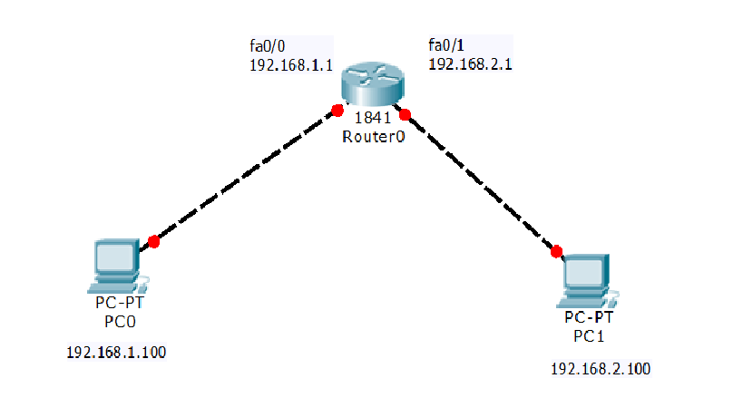

Sharing of a packet between two PCs using a router